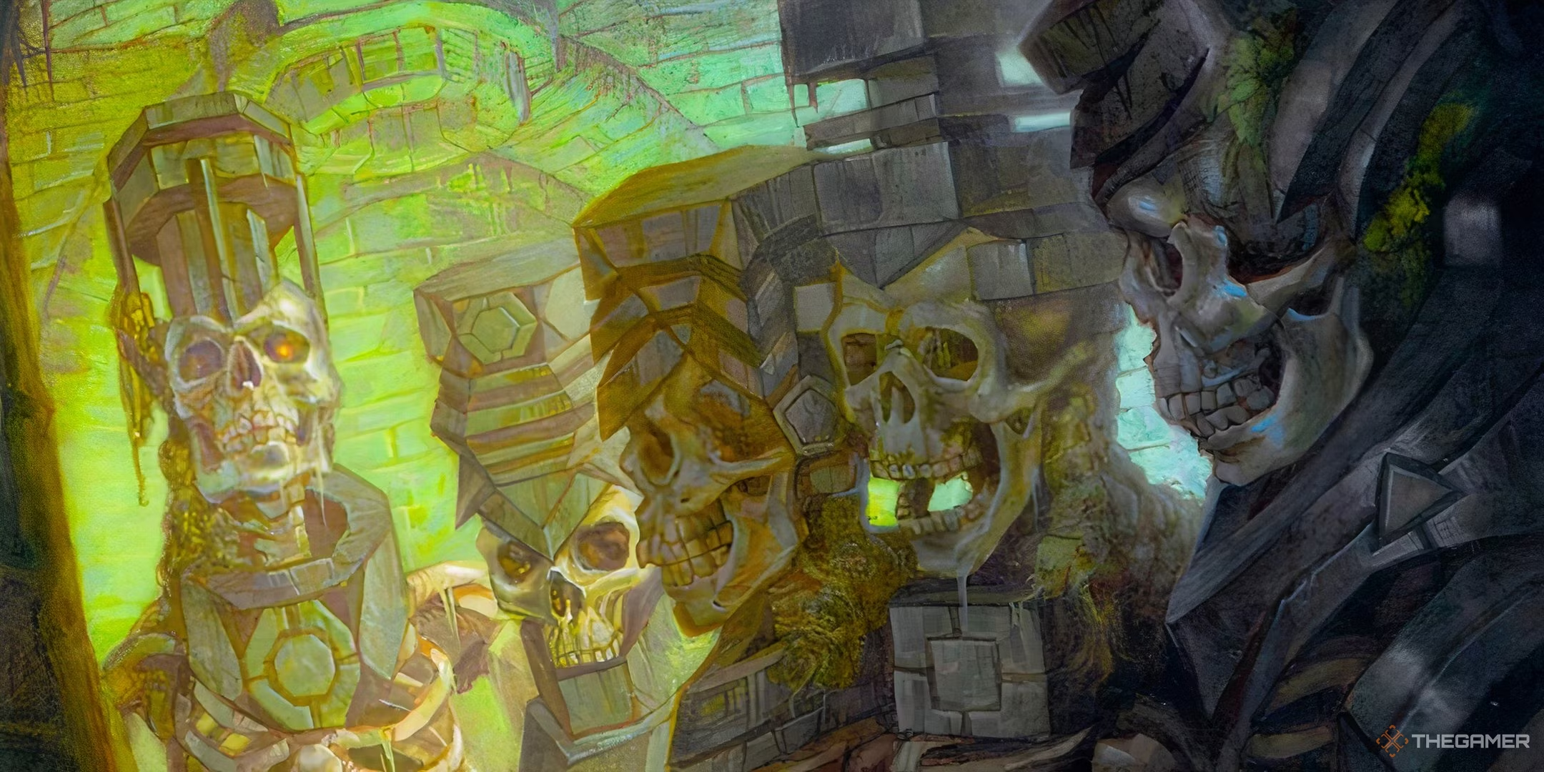
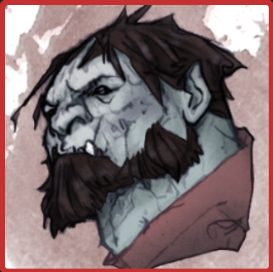

Zwargie

“The Brute Squad”
Campaign Book
(Tomb of Annihilation)

